**ASSIGNMENT - 5**

**PROBLEM STATEMENT -** Create a Public Bucket. Upload a file and give the necessary permissions to check

whether the file URL is working.

**To create Public Bucket**

STEP 1- Click on the “S3” button.

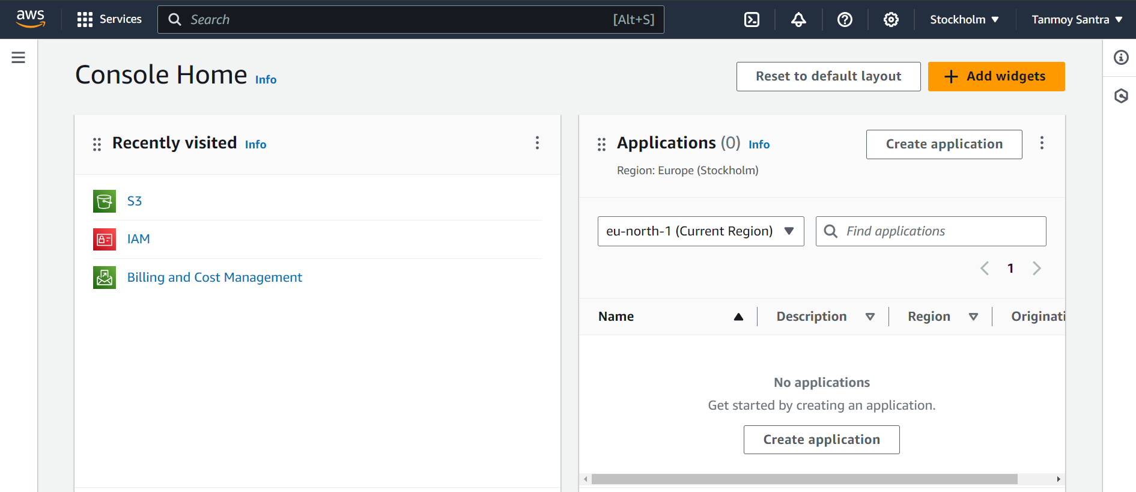

STEP 2- Click on “Create Bucket”.

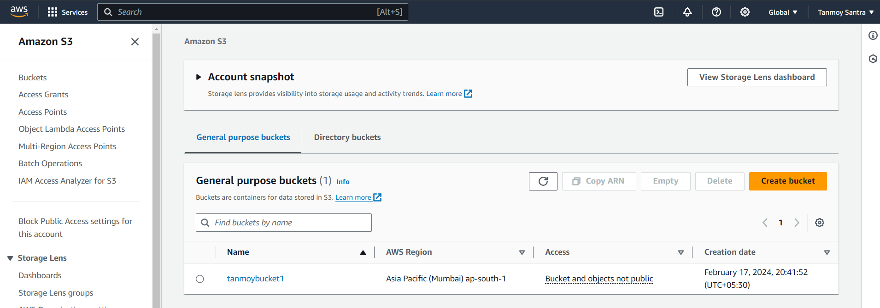

STEP 3- Select “Mumbai”, give a Name to the Bucket. Select “ACLs enabled”

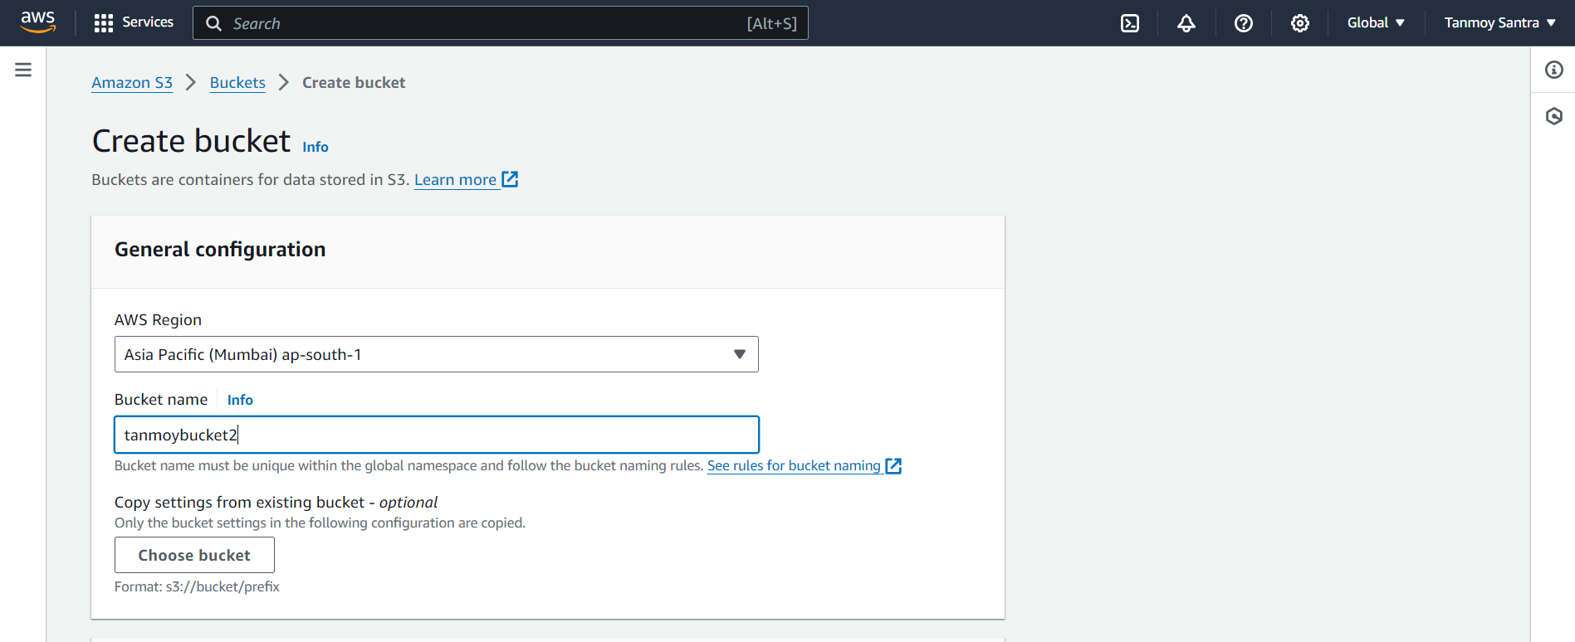

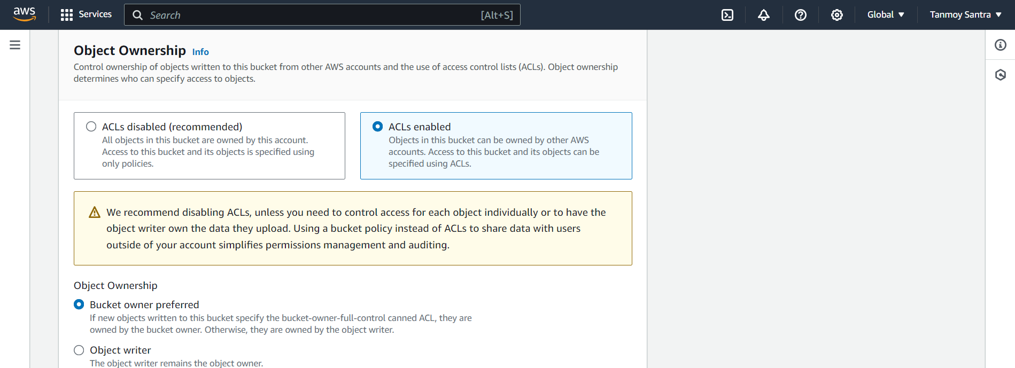

STEP 4- Click “Block all public access” & tick the “I acknowledge” checkbox.

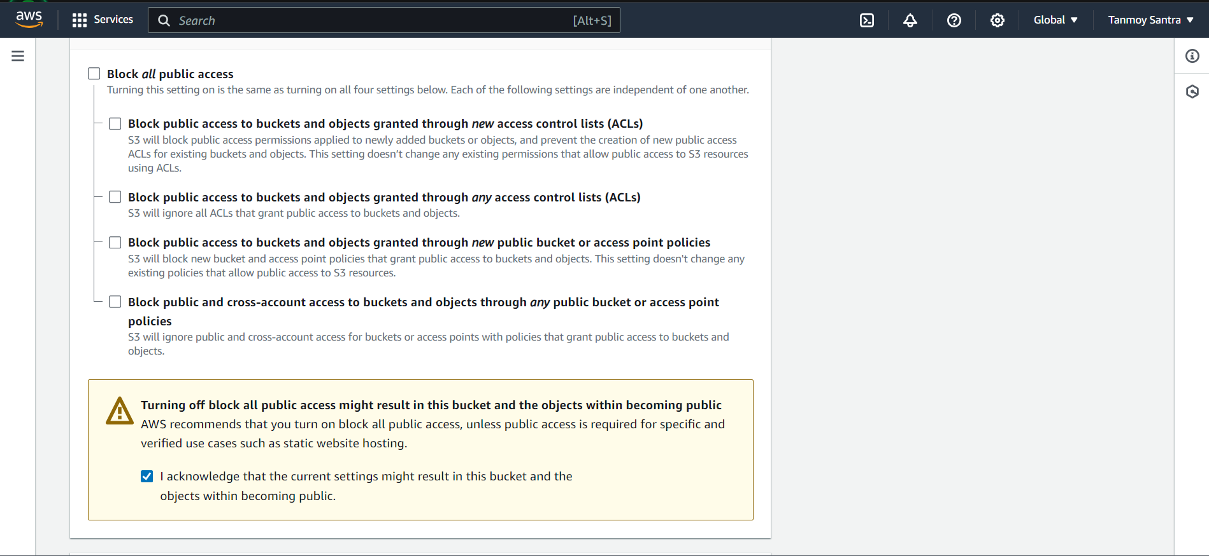

STEP 5- Click on “Create Bucket”.

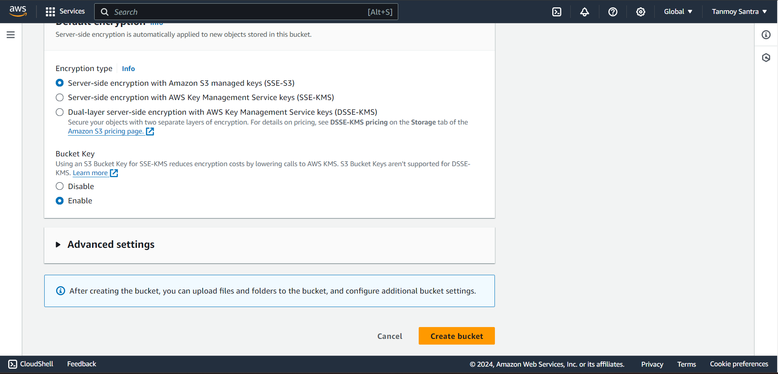

STEP 6- The Bucket is created. Click on the bucket name.

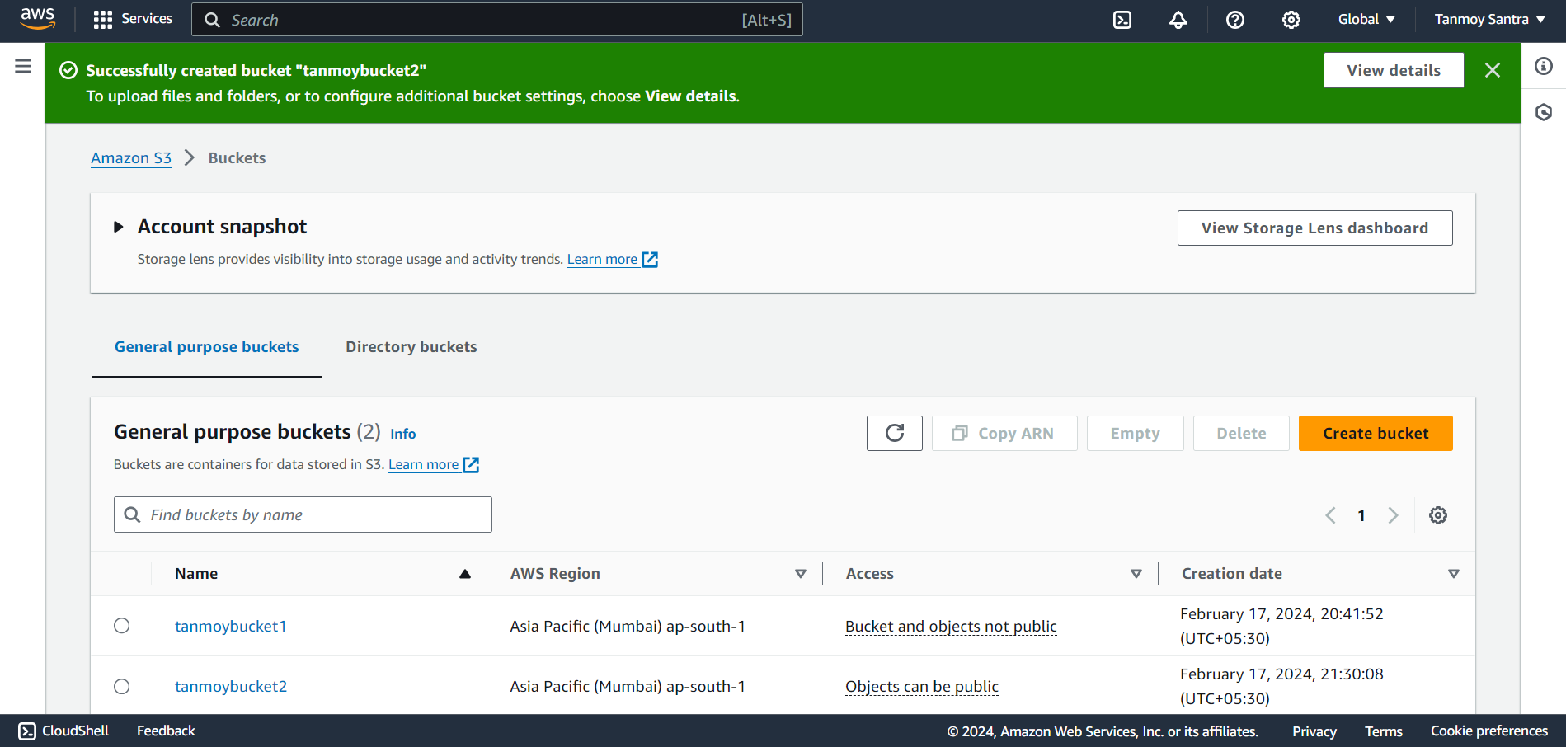

STEP 7- Click on the “Upload”.

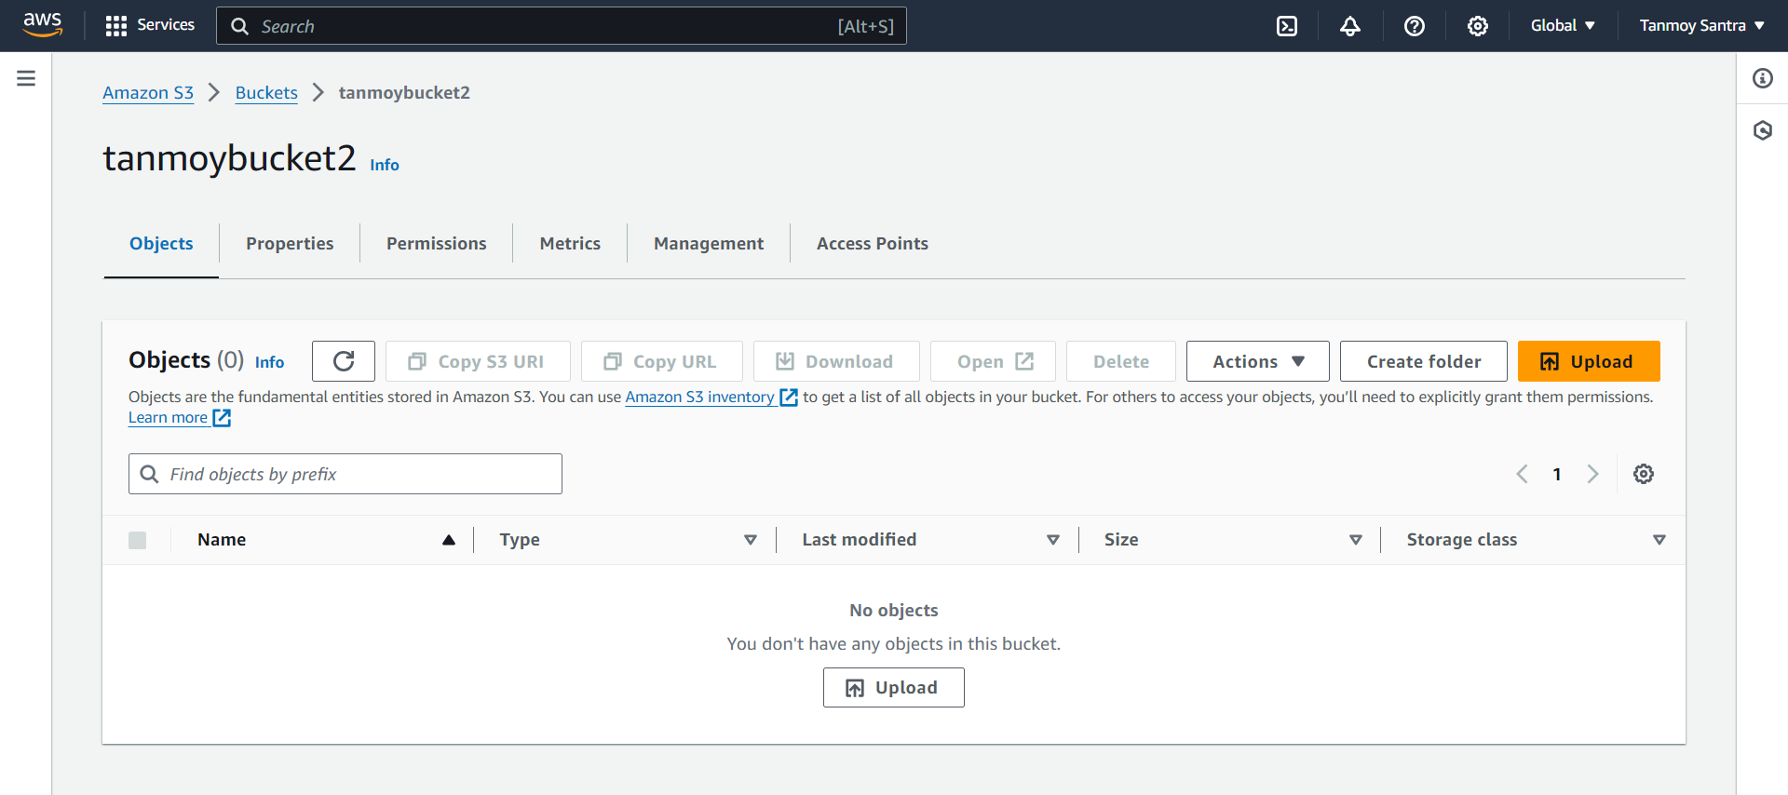

STEP 8- Click on “Add file”. Click “upload”.

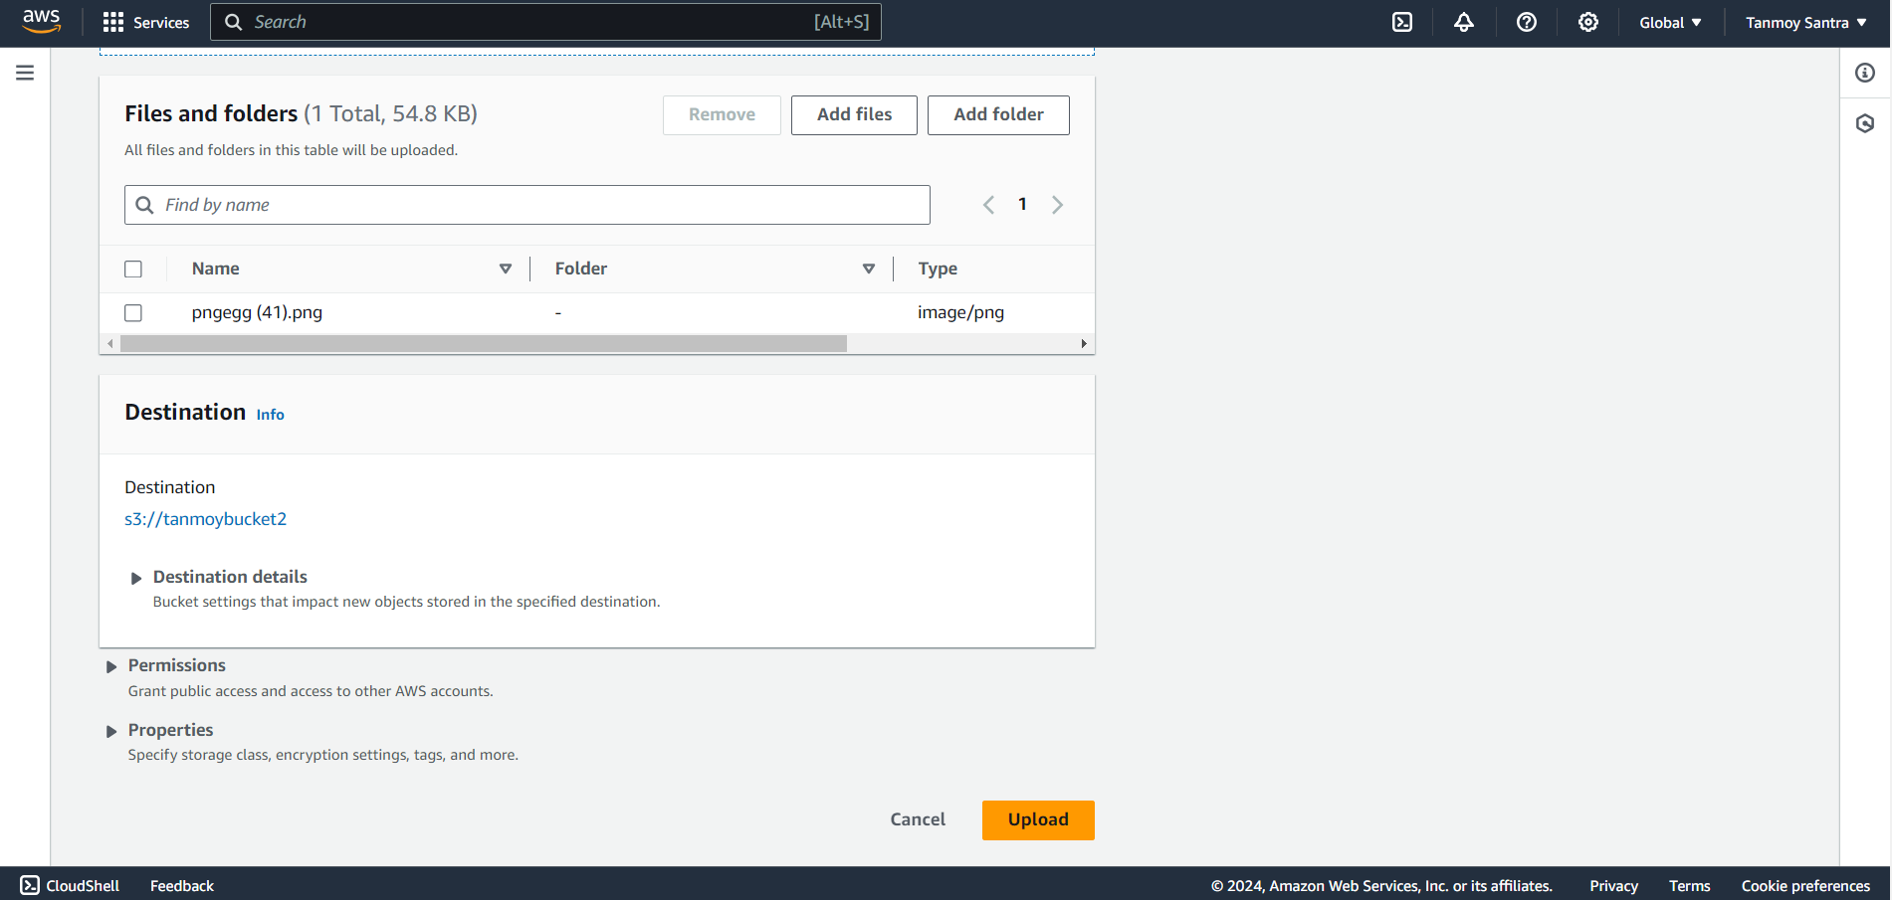

STEP 9- The file has been uploaded.

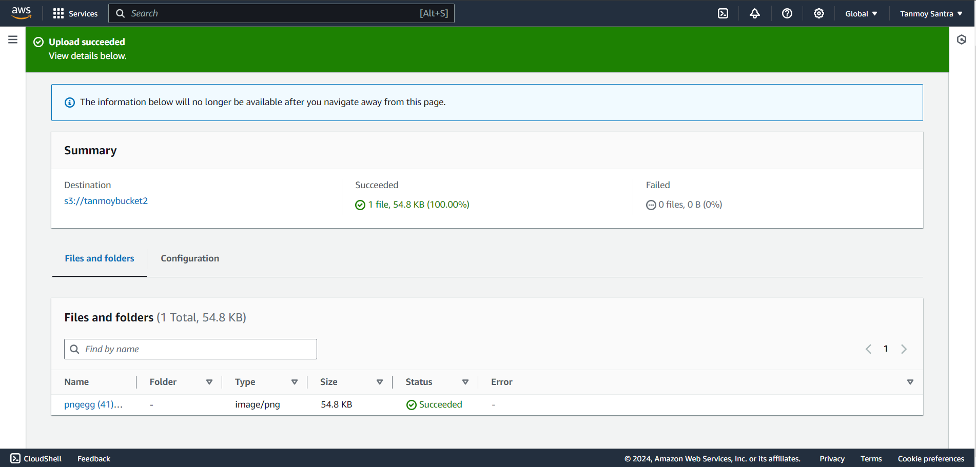

STEP 10- Click on the “Permissions”.

STEP 11- Click on the “Edit”.

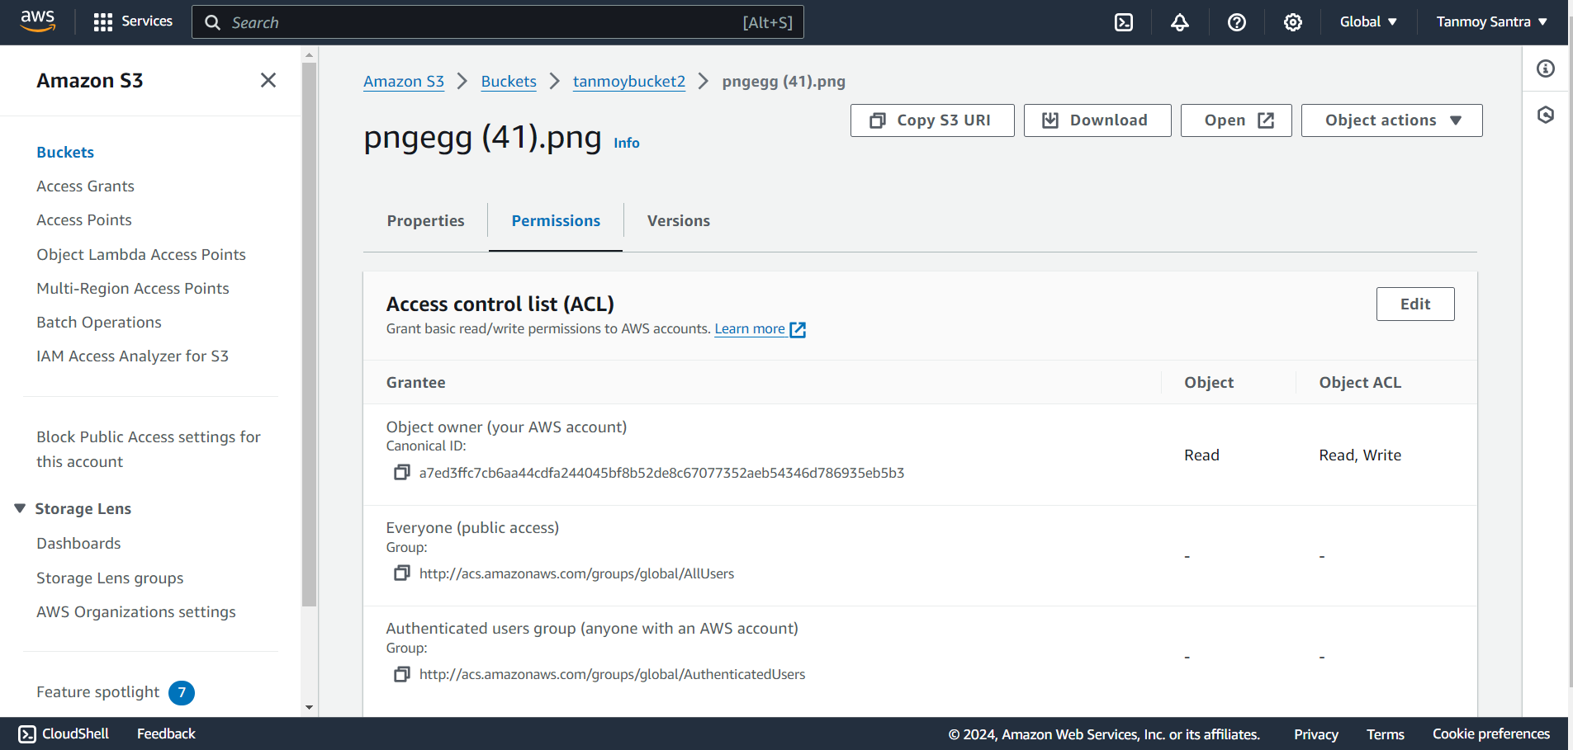

STEP 12- Give the “Read” permissions.

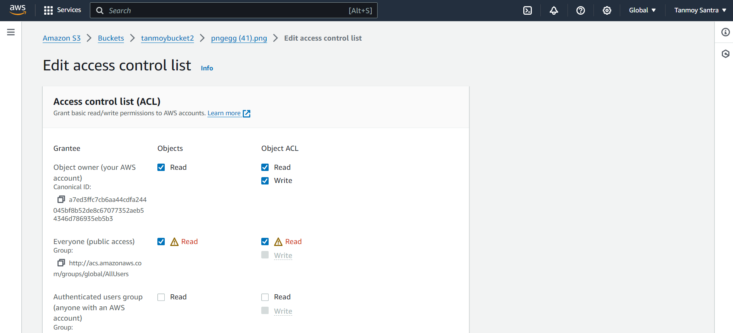

STEP 13- Click on “Save Changes”.

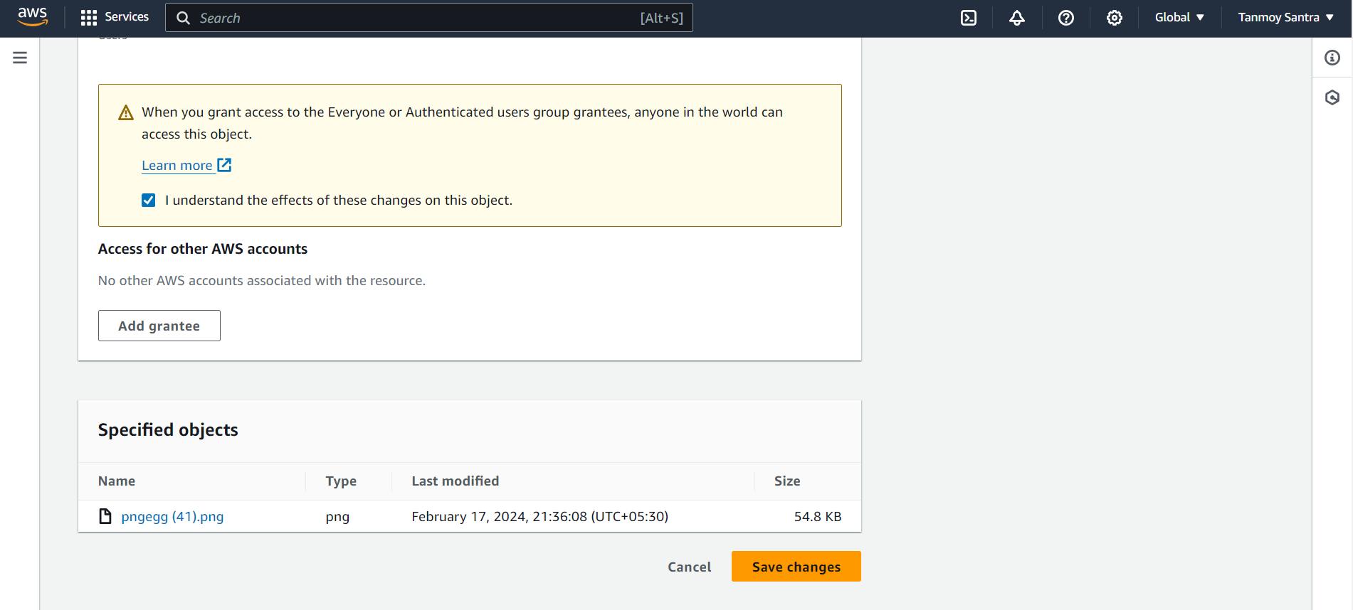

STEP 14- Copy the “Object URL”.

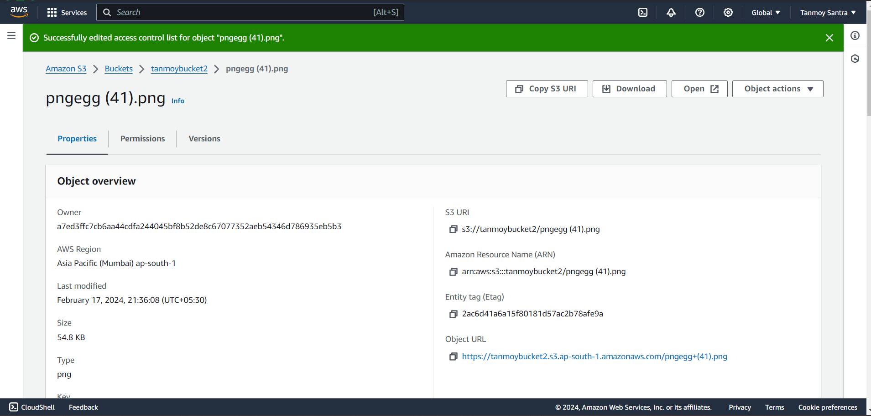

STEP 15- Open a new window and paste the URL in the address bar.